Time Series Analysis of the Istanbul stock index

Huijun Hao(SID:862024305)

Abstract

The purpose of this study is to analyze the change rate of stock index and predict its trend by identifying a model that is best fit to predict the rate of change of ISE 100 index. Parameter of the model and forecast of future rate of change of Istanbul National 100 Index was estimated by maximum likelihood. The rate of change of ISE index data from Jan 9, 2009 to February 22, 2011 indicate that the rate of change of the stock index is a white noise process with identical independent t distribution with mean 0.16%, but it is not statistically different from 0. It means that the expected return rate of ISE 100 index is very small everyday but in the long run stock can still be profitable. According to data, the expected value of return rate remained very stable throughout the time but there are some outliers in the data which is four standard errors away from the mean. It reflects the risk of rewards for stock investment.

Introduction

*Background of stock index*

The stock of a corporation is the share of ownership of a corporation. If the corporation is making profit, the value of the stock will increase, and the owner of the stock will also gain wealth. In contrast, if the corporation is not making profit, the stock value of the corporation will remain the same or decrease, and the owner of the stock will lose wealth. In order to measure the trend stock price of different companies, many countries created their own stock index to measure the trend of stock.

Stock index measures the section of the stock market. Prices of specific stocks are computed according to weight average to form stock index. Different stock index measures different stocks price from different company. Thus, stock index can be a very useful tool for people to describe the market. Since it is an index that measures the stock prices of certain corporation, stock index can also reflect the economy indirectly. The data set contains the stock exchange return rate of eight international index from January 5th, 2009 to February 22nd, 2011. Stock return rate means the rate of change in stock value. In the dataset, SP is S&P 500 index. This index measures the stock performance of the 500 largest companies that are in the stock market in the United States. DAX is a stock market index that measures 30 major companies that are listed in Frankfurt Stock Exchange. FTSE, or FTSE 100 index, is the index that contained 100 companies on the London Stock exchange. NIKKEI index contains 255 companies in the Tokyo Stock exchange. BOVESPA index contain 60 companies in Brazil Stock Exchange. MSCI Eu index contains 422 companies across Europe, and MSCI EM contains 1202 companies across 26 emerging market. Istanbul Stock market is also called “The Borsa İstanbul” is the sole exchange entity of [Turkey](https://en.wikipedia.org/wiki/Turkey) combining the former Istanbul Stock Exchange (ISE). Shareholders of Borsa İstanbul are: 49% Government of Turkey, 41% IMKB, 5% VOB, 4% IMKB members, 1% IMKB brokers and 0.3% IAB members (Güler, Hülya 2013).

*The Turkey stock market index*

Stock market index are playing an important role in the overall analysis of the Turkey equity market. Indexes and their movement can provide a great prediction or description of what is the Turkey market looks like. In Turkey, the most representative indexes that was mostly broadly followed by the media and investors, which is ISE National 100 Index. ISE National-100 Index contains ISE National-30 and ISE National-50 Index. ISE National 100 Index is an indicator of the whole economy of Turkey.

Unlike other countries that have varies companies, In Turkey, The Borsa Istanbul(BIST) is the only stock exchange operating on theTurkey stock market. It was combies the former Istanbul Stock Exchange, the Istanbul Gold Exchange and the Derivatives Exchange in Turkey. In Turkey, there are approximately 370 companies that were listed in the Borsa Istanbul. From Borsa Istanbul, it involves many companies, such as Kardemir,Sabanci Holding, Bimeks, Petkim and Zorlu Enerji, which are the most popular ones on Turkey. From all of those companies, its market cap amounts ito 221$ billion (Tradingview,2019).

Recently, the Borsa Istanbul 100 index, which is the benchmark of Turksih stocks, was dropped about 7% of its total value compared with its original stock value. The reason is because Turkish troops began crossing into northern Syria. The change of Turkey’s stock was actually a sign of threats and warnings of sanctions from U.S. and some other country(Bloomberg).

The aims of the Istanbul index study are 1)to identify a possible model for the return rate of Turkey stock index data, and 2)to forecast the trend and the value of the change of future stock market through the entire Turkey equity market; since the Turley’s market is now dropped by 7%, people want to know if this drop is temporary or not. By forecasting the trend of the change of the stock market, it can give people a general output and trend of how stock will be for the future market, and it can also give people advice about whether a stock will be worth for people to buy or sell stock.

**Data**

The data that we study is stock return rate of Istanbul stock exchange national 100 index. The data was collected daily to show the return rate of the Istanbul Stock Exchange 100 Index each day when the stock market opened. The Istanbul stock index is measured by averaging the largest 100 companies that were listed in the stock market and showed the trend of average stock prices of these companies. The data that we studied is the return rate of stock prices on average of these 100 companies. Y-lab of the plot indicates the return rate of the stock index, and the x-lab showed the day of the stock return. The data contained 536 observations from January 9, 2009 to February 22, 2011. The data were collected each day the stock market that was opened. The following section include model specification, model fitting, residuals analyzed. All analyses were performed in R.

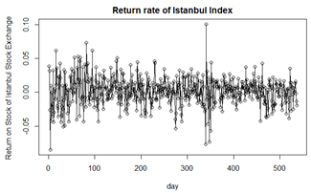

Figure 1: Scatterplot for the stock return rate of ISE 100 Index

**Model Specification**

In the Figure, Yt is the value of Y at time t where Y is the return rate according to the stock index, and t is in day. The plot shows the return rate of Istanbul Stock Return Index from January 9, 2009 to February 22, 2011. Total of 536 data are observed. According to the scatterplot, it seems that there is no upward or downward trends, and moves horizontally at time increases, but variance may not be constant since there are a few outliers that are far away from the mean. In this study, we will use ARIMA(p,d,q) model to analyze this time series data. In ARIMA(p,d,q), p refers to the order of autoregression, q refer to the order of moving average in the model, and d refers to the number of differencing in order to make the data stationary to determine ARMA order.

**Transformation**

Before we fit the ARIMA model, first we want to minimize variance in the data. According to the figure, we already detected some outliers in the data. By transforming the data, we can stabilize the variances. The transformation method that we used in this study is power transformation by Box and Cox (1964). The Box Cox transformation is defined by

Where λ is a parameter for power transformation.

According to power transformation by Box and Cox, 95% confidence interval of λ is shown in figure 2. The 95% confidence interval is very wide, and it ranges from -1 to 4. Because λ = 1 is included in the 95% confidence interval, we decide that no transformation is needed for this data set since T(Yt) = Yt1 = Yt.

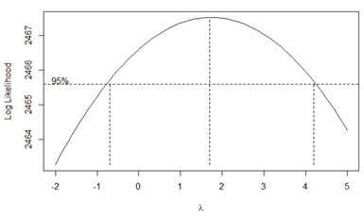

Figure 2: BoxCox power transformation

**Test for Stationary**

The second step that we do is to test stationary for the data. Because both autoregressive and moving average are models for stationary process. If the data are not stationary, we may need to take a difference in order to transformed data into a stationary process. Differencing is a process that takes a difference between the current data and the previous data in order to detrend that data and to make into a stationary process. In this study, we use Augmented Dickey-Fuller test by Dickey and Fuller to test stationary. In this test, the null hypothesis is that the data are not stationary. Where alternative hypothesis is that the data stationary. We set 5% as our type I error rate. According to the R output, p-value is 0.01 (Output 1 in the appendix), which is smaller than the type I error rate. Since the null hypothesis is rejected at 95% confident, there are sufficient evidence to indicate that the data are stationary. Since we conclude that the data are stationary, we do not need to take differencing.

**Model Specification**

After we do the power transformation and stationary test, we need neither to transform the data to stabilize variance nor to take differencing to make the data stationary. Thus, we can select an ARMA model for the original data. First, we plot sample ACF and PACF to see if there are any significant autocorrelation for different lag. Figure 3 shows the sample ACF and PACF, where the margin of error bounds are calculated by (+/-)*2/sqrt(536) = (-0.08638684, +0.08638648). If there are any autocorrelation exceeds the margin of error bounds, it indicates that there is a significant autocorrelation.

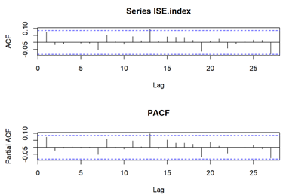

Figure 3: ACF and PACF

According to the ACF and PACF plot, there is not any significant autocorrelation, which suggests that ARIMA(0,0,0) may be our candidate model. In order to further confirm our model selection, we also plot an EACF plot in figure 4 to support our selection.

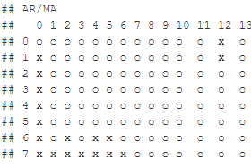

Figure 4: Extended ACF

In the EACF plot, we observed that there are two x at (0,12) and (1, 12); we assume that these two x are false positive. EACF plot suggest that a wedge with a tip at ARMA(0,0), which indicates that the dataset is a white noise process.

**Model Fitting and Diagnostics**

**Model Fitting**

According to EACF plot, we suggest that ARMA(0,0) is our candidate model. ARMA(0,0) is a white noise process. Model of white noise is expressed as below:

Yt =0.0016+ et

Where et is an independent identical distribution. Then we use maximum likelihood to estimated mean of et. According to output 2 in appendix, maximum likelihood suggest that mean of et is 0.0016. Then we test if mean of et is significant by constructing a 95% confidence interval.

0.0016 +/- 1.96*0.001 = (-0.00036,0.00356)

Since 0 is in the 95% confidence interval, we conclude that mean is not significant from 0, and it may be a zero mean white noise process.

**Model Diagnostics**

After we fit the ARMA(0,0) model, which is a white noise process, we want to find the distribution of the white noise process. Since white noise process have an independent identical distribution, we can find the distribution of the white noise process by analyzing the residuals. Moreover, the normality assumption is also not needed to be satisfied since white noise is an independent identical distribution that not only limited to normal distribution. According to the residuals plot in the figure 5, distribution of residuals is symmetric, and qq plot also suggest that it may be a normal distribution. Residuals in residual plot also show no quadratic trend.

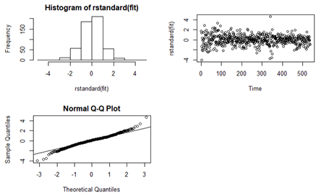

Figure 5: Residuals Diagnostics

Then we use Shapiro-Wilk normality test to test if this white noise process follows a normal distribution. In Shapiro-Wilk normality test, the null hypothesis is that the data are normally distributed, and the alternative hypothesis is that the data are not normally distributed. In the output 3 in the appendix, p-value of normality test is 0.000002966, which is very small. We set type I error rate at 5%. Since the p-value from the test is smaller than the type I error rate, we conclude that there is insufficient evidence to indicate that the residuals are normally distributed.

Independent Assumption - Because white noise process is an independent identical distribution, we also need to test the independence of the residuals. We use runs test to test independence of residuals. Null hypothesis for runs test is that the residuals are independent, and the alternative hypothesis is that the residuals are not independent. According to output 4 in appendix, p-value for the runs test 0.478. We set type I error rate at 5%. We fail to reject the null hypothesis. There is sufficient evidence that the residuals are independent. In figure 6, ACF plot of residuals also suggest that there is no significant correlation between residuals. Since distribution of the residuals is symmetric but we reject the null hypothesis in the normality test, and runs test suggest that the residuals are independent, we conclude that the white noise process may be an independent identical Student-T distribution.

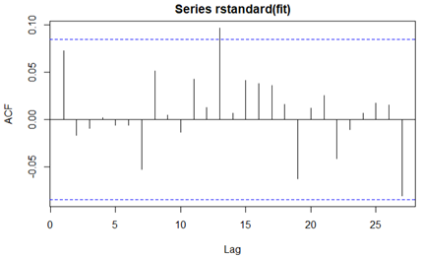

Figure 6: ACF plot of residuals

Overfitting – We also consider overfitting our model by using AR(1) and MA(1). Again we use maximum likelihood to estimate parameter for overfitting model. First we find parameter for AR(1) model. According to Output 5 in appendix, estimation of φ is 0.0728 and standard error is 0.0432. 5% confidence interval for φ is

0.0728 +/- 1.96*0.0432 = (-0.011472, 0.1578722)

Since 0 is in the confidence interval, φ is not statistically significant, which suggests that AR(1) is not necessary. The standardized residuals of AR(1) is symmetric but normality test also against normality assumption (See Figure 7 and Output 6 in appendix).

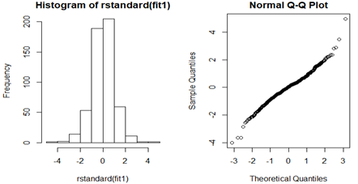

Figure 7: residuals of AR(1)

Then we try MA(1) as another overfit model. According to Output 7 in appendix, estimation of θ is 0.0754 and standard error is 0.0432. 5% confidence interval for φ is

0.0754 +/- 1.96*0.0432 = (-0.010448, 0.161248)

Since 0 is in the confidence interval, θ is not statistically significant, which suggests that MA(1) is not necessary. The standardized residuals of MA(1) is symmetric but normality test also against normality assumption (See Figure 8 and Output 8 in appendix).

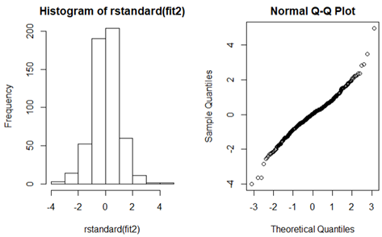

Figure 8: residuals plot of MA(1)

Since both overfitting models are not statistically significant and normality assumption is violated, we will use ARMA(0,0) as our final model.

**Forecasting**

To compare our model is actual values, we withhold the last 5 observations, which are Feb 16, Feb 17, Feb 18, Feb 21, Feb 22 in 2011. Because our model is a white noise model, expected value of prediction is the mean of the white noise model.

E(Yt) = E(0.0016 + Xt)

= 0.0016

Because Xt is a zero-mean t-distribution, mean of Xt is 0, and the variance is the variance of the data from t-distribution. Then we compare our model with the last 5 observation.

As the table above presented, observed value is not significantly different from the prediction value. Because the model that we fitted is a white noise model, each data is independent from other. Thus, prediction value, and lower and upper confidence intervals remain fixed as time passes. The return rate of Istanbul Index remained constant, which is very reasonable because the average of large companies has a stable growth.

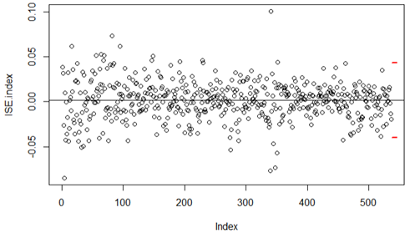

Figure 11: Prediction of future.

**Discussion**

By using maximum likelihood estimation, we identified that white noise model fit the return rate of Istanbul Stock Exchange Index. The estimated parameter is

Yt = 0.0016 + Xt

In this study, we identified that Yt is an independent identical t-distribution with mean equal to 0.0016. It means that Istanbul Stock Exchange Index has mean growth rate with 0.16% every day from 2009 to 2011. It is reasonable that the return rate of a stock index is a white noise t-distribution because Istanbul Stock index is measured by averaging the 100 largest companies in the stock exchange market. And rate of return of the index is the rate of return of average of the 100 largest companies.

Moreover, this model has a limitation because stock prices are determined by many conditions and its economy environment. The model can only useful if the economic environment remained fixed.

Because the return rate that we analyze follow a t distribution, there are approximate 50% chance with negative return even though the mean of every day return rate is 0.16%. It suggests that the risk of investment in stock market is very high if analyze the return rate daily. However, in the long run, there is a large chance to make profit from the stock market.

**Citation**

Akbilgic, O., Bozdogan, H., Balaban, M.E., (2013) A novel Hybrid RBF Neural Networks model as a forecaster, Statistics and Computing. DOI 10.1007/s11222-013-9375-7.<https://archive.ics.uci.edu/ml/datasets/ISTANBUL+STOCK+EXCHANGE>

Güler, Hülya (2013-04-04). "Borsa'da lâle devri". Hürriyet Ekonomi. Retrieved 2013-04-05.

ISE.org Archived 2006-11-29, <https://web.archive.org/web/20061129090738/http://www.ise.org/>

*Bloomberg.com*, Bloomberg, <https://www.bloomberg.com/news/articles/2019-10-14/charts-show-bearish-signs-on-turkish-stocks-as-rout-accelerates>.

“Stock Trading Ideas and Overview - Turkey.” *TradingView*, <https://www.tradingview.com/markets/stocks-turkey/>.

**Appendix**

**Output 1 Augmented Dickey-Fuller Test**

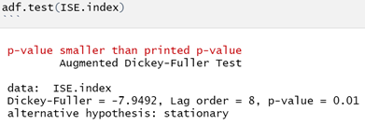

Ho: data are not stationary

Ha: Data are stationary

P-value < 0.01 < alpha = 0.05

Reject Ho. There is sufficient evidence to indicate that return rate of Istanbul Stock Exchange Index is stationary. In other words, Yt is stationary.

**Output 2 ARMA(0,0) model fitting**

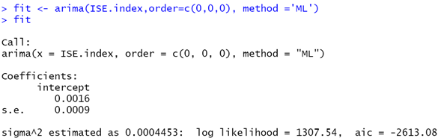

**Output 3 Normality test for ARMA(0,0) residuals**

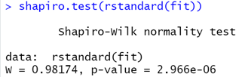

Ho: residuals are normally distributed

Ha: residuals are not normally distributed

P-value = 0.000002966 < alpha = 0.05

Reject Ho. There is sufficient evidence to indicate that the residuals are not normally distributed.

**Output 4 Runs test for residuals**

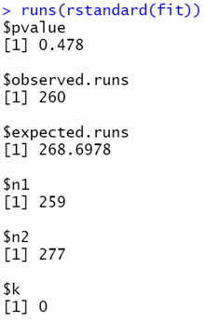

Ho: Residuals are independent

Ha: Residuals are not independent

P-value = 0.478 > alpha = 0.05

Do not reject Ho. There is sufficient evidence to indicate that the residuals are independent.

**Output 5 Model Overfitting AR(1)**

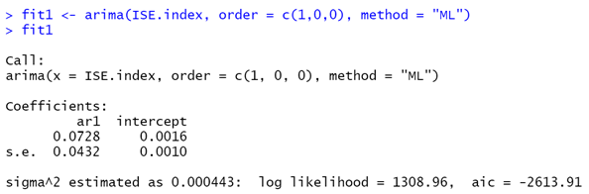

**Output 6 Normality and Independent test for AR(1)**

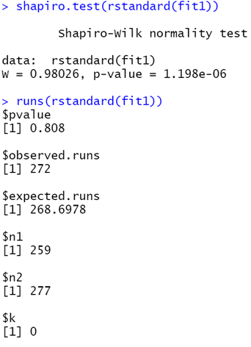

Test for normality

Ho: residuals are normally distributed

Ha: residuals are not normally distributed

P-value = 0.000001198 < alpha = 0.05

Reject Ho. There is sufficient evidence to indicate that the residuals are not normally distributed.

Test for Independent

Ho: Residuals are independent

Ha: Residuals are not independent

P-value = 0.808 > alpha = 0.05

Do not reject Ho. There is sufficient evidence to indicate that the residuals are independent.

**Output 7 Model Overfitting MA(1)**

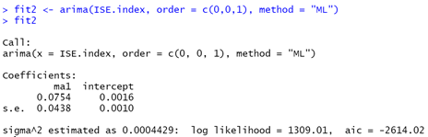

**Output 8: Normality and Independent Test for MA(1)**

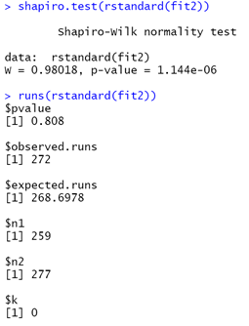

Test for normality

Ho: residuals are normally distributed

Ha: residuals are not normally distributed

P-value = 0.000001144 < alpha = 0.05

Reject Ho. There is sufficient evidence to indicate that the residuals are not normally distributed.

Test for Independent

Ho: Residuals are independent

Ha: Residuals are not independent

P-value = 0.478 > alpha = 0.05

Do not reject Ho. There is sufficient evidence to indicate that the residuals are independent.